<https://github.com/julixec/cursopython>

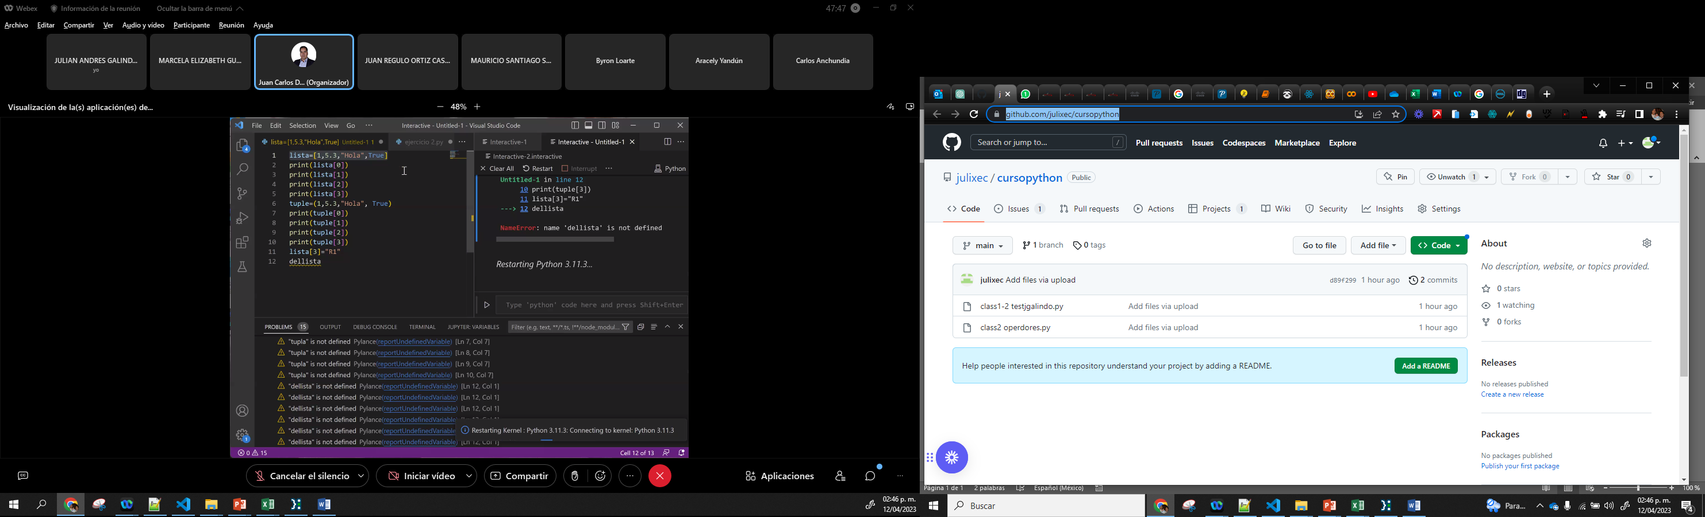

<https://github.com/users/julixec/projects/1/views/1>

